**Day-3 (10-1-18)**

* mysql -u root -p
* show databases;
* create database csd2204w18;
* use csd2204w18;

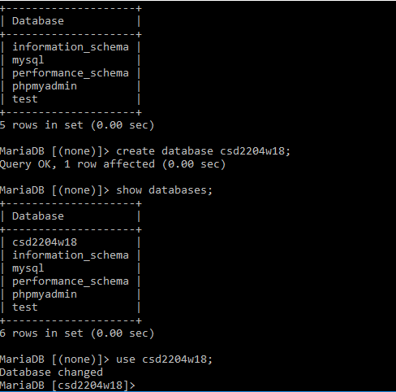

* Show tables;
* create table c1(

-> customerID int(2),

-> name varchar(20),

-> nickname varchar(20),

-> address varchar(50),

-> city varchar(20),

-> postalcode int(6)

-> );

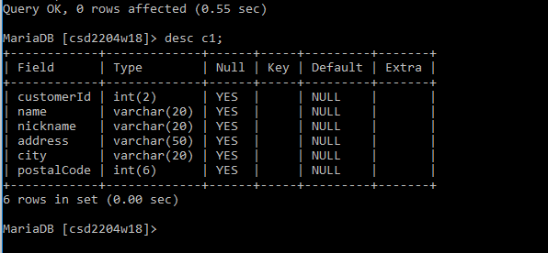

* show tables;

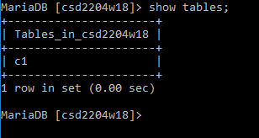

* show create table c1;

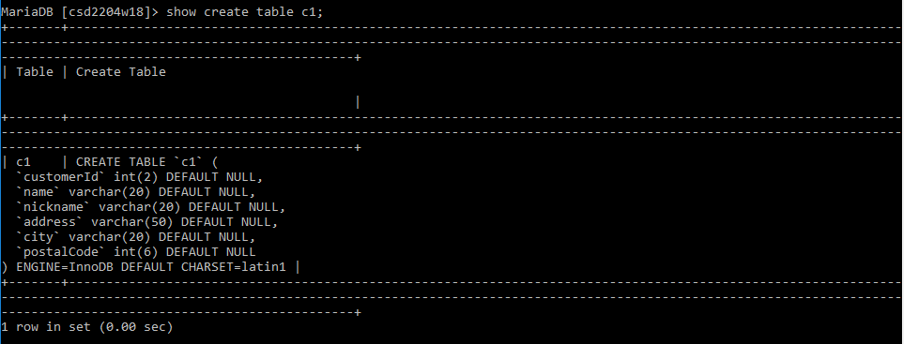

* insert into c1 values(1,'Jaydeep','JD','NorthYork','Toronto',123456);

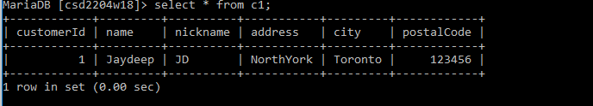

* insert into c1 values(1,'Ashley','Ash','32 Washington Street', 'WDC',321200);
* insert into c1 values(2,'Bob Marley','Bm','32 Keele Street', 'Toronto',100100);
* insert into c1 values(3,'Cherlies Theron','Cher','329 Empire State Building', 'New York',120134);
* insert into c1 values(4,'Denial Jack','DJ','Sparton Bulding East', 'Brazil',341020);
* insert into c1 values(5,'Donna Newman','New','250 Carlson Blvd', 'Toronto',130120);
* insert into c1 values(6,'Eston M.','M.','21 York. DV.', 'Toronto',201023);
* insert into c1 values(7,'Bobby Chacko.','Chac','Kennedy', 'New York',320300);
* insert into c1 values(8,'Ashko Charles','AK','Washington D.C.', 'USA',421044);
* insert into c1 values(9,'Tony Special','Specie','Oakville', 'GTA',418921);
* insert into c1 values(10,'Jack Sp','Sparrow','Oaster village', 'New Jersey',102301);

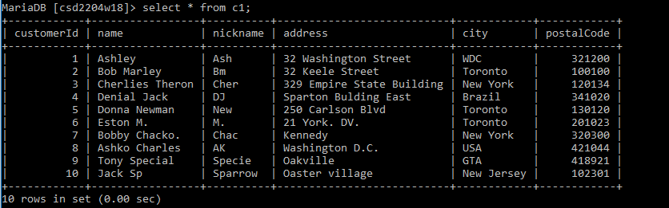

* select * from c1 WHERE city='Toronto';

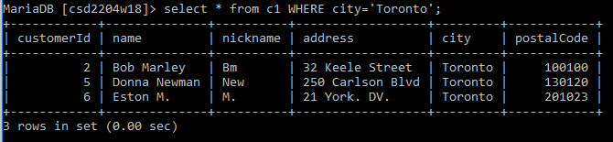

* select * from c1 WHERE name='Ashley';

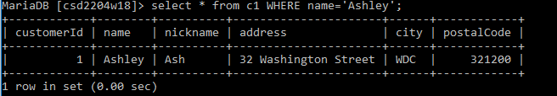

* select * from c1 WHERE city='Toronto' OR city='New York';

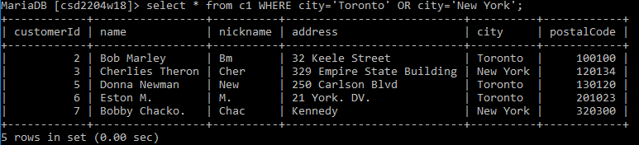

* select * from c1 WHERE city='Toronto' AND nickname='Bm';

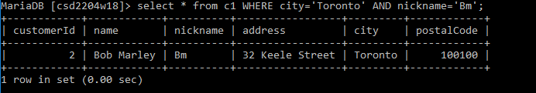

* select * from c1 WHERE customerId=4 OR customerId=6;

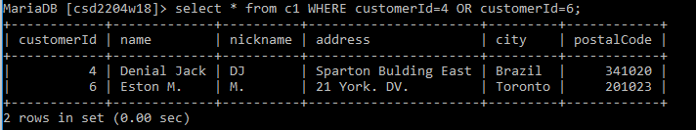

* select * from c1 WHERE customerId between 2 and 7;

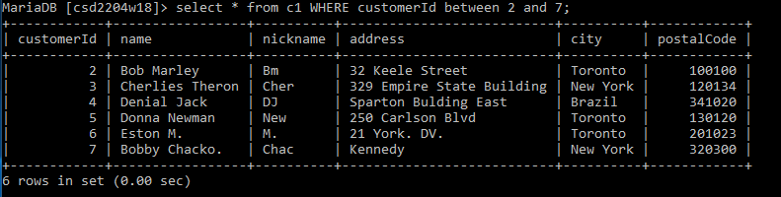

* select * from c1 WHERE nickname between 'Bm' AND 'New';

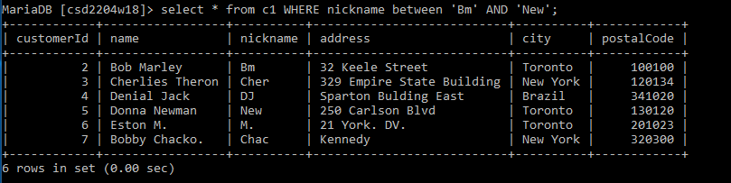

* select * from c1 WHERE name LIKE'D%';

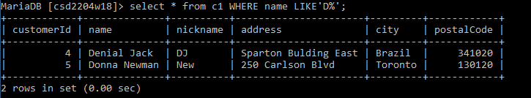

* select * from c1 WHERE city LIKE'N%';

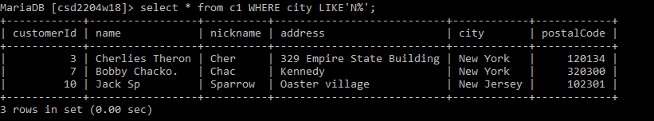

* select * from c1 WHERE name LIKE'_o%';

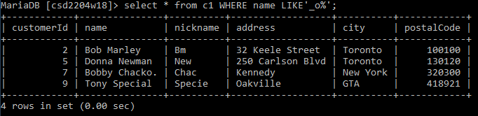

* select * from c1 WHERE name LIKE'_on%';

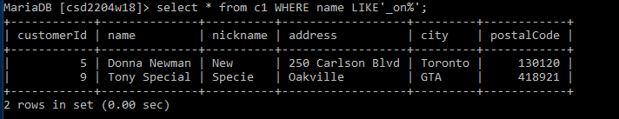

* select * from c1 WHERE name LIKE'D%' AND city='Toronto';

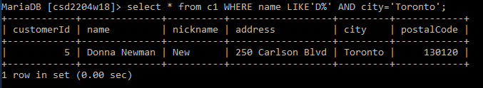

* select * from c1 WHERE customerId IN(2,4,7,9);

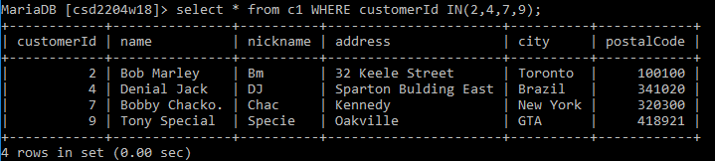

* select * from c1 WHERE nickname IN('Bm','DJ','New');

